Want to make a line following robot……..? Let’s do it....!
What do you require to make a line follower...?
- Good sensors
- Motors
- And some intelligence....

Let’s see how to make good sensors to follow the line…
As we know that we have to follow the black line on white surface or white line on black surface… it means we have to detect white and black surface
So how would be our sensors…?
Our sensors should reflect from any of these surfaces…
As we are using the property of reflection so “Infrared Light (IR)” would be an ideal choice…
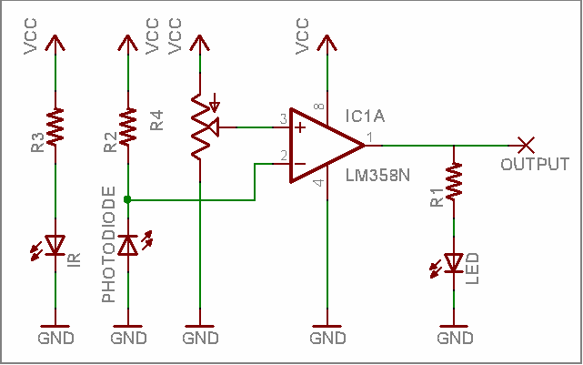
Because IR not get affected by other light so now the question Is how to use IR...?

Circuit diagram for making IR sensors...
What are you looking at when you think of a line follower??
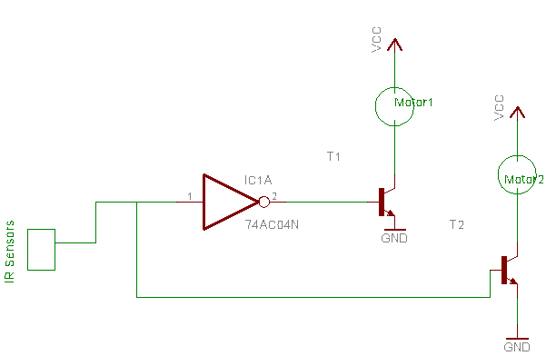
-It should follow the line as fast and unwavering as possible. Some useful guidelines are for a line…
-Sensors should be placed as far away from the motors as possible so that we have enough time to change motor direction.
-The weight of the machine should be evenly balanced
-Construction of the robot and sensor placement will depend upon the speed of the motors to be used
steps to follow the line (using single sensor):
-Start
-Check for line
-Line detected go right
-Check for line
-If no line turn left till line detected

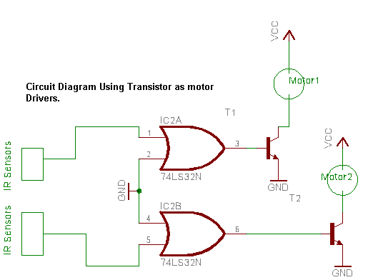
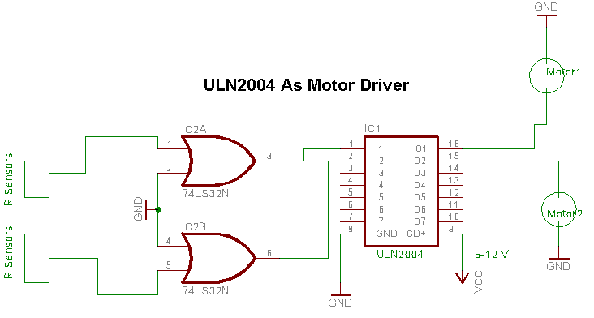
Algorithm for building a line follower (using two sensors):
-Start
-Check for line
-If both sensors are on line go straight
-If only left sensor is on the line, turn left till both sensors are on the line
-If only right sensor is on the line, turn right till both sensors are on the line

other motor drivers are L293D ,L298 and ULN200x. Datasheets for the same are available on www.alldatasheets.com

